Contribution Title in English
Contribution Title in Italian
Name of First Author and Name of Second Author
Abstract The abstract should be written in English and in Italian, each paper should be preceded by an abstract (no more then 10 lines long) that summarizes the content. Please insert your abstract here.
Abstract Abstract in Italian

Key words: key word 1, key word 2,...
- Section Heading
Use this like a template.
Instead of simply listing Section headings of different levels we recommend to let every heading be followed by at least a short passage of text. Please note that the first line of text that follows a Section heading is not indented, whereas the first lines of all subsequent paragraphs are.
  - Subsection Heading
Instead of simply listing Subsection headings of different levels we recommend to let every heading be followed by at least a short passage of text. Please note that the first line of text that follows a Subsection heading is not indented, whereas the first lines of all subsequent paragraphs are.

- Example of Table
Please use Table 1 and Figure 1 like a template to insert tables and figures in the paper.

Table 1: Please use the caption style here
… | … | … | …
… | … | … | …
… | … | … | …
… | … | … | …
… | … | … | …

Figure 1: Please use the caption style here 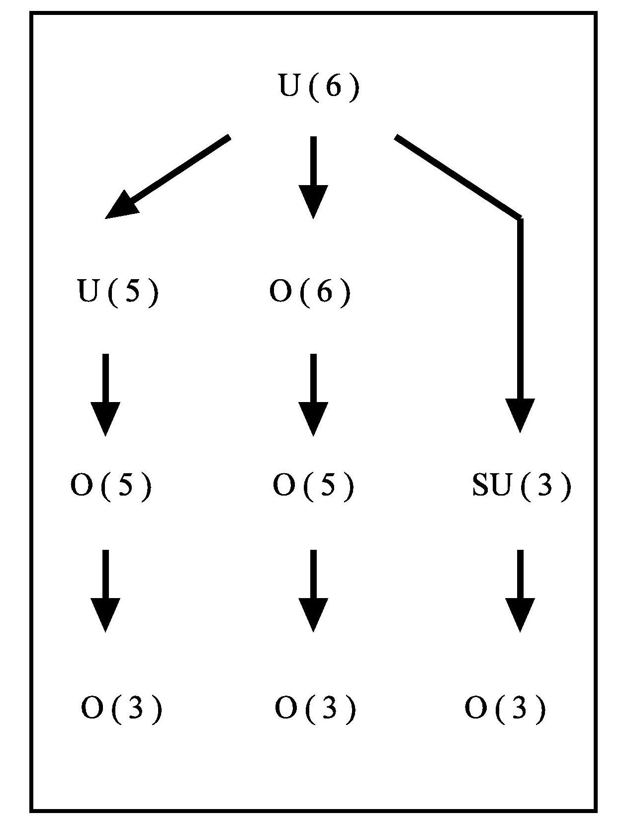
- Citations and References
References may be cited in the text either by number (preferred; e.g., [1], [2,3], and so on) or by author/year (e.g., Name of Author(s), (1998)). Make sure that all references from the list are cited in the text.
The reference list should ideally be sorted in alphabetical order, even if reference numbers are used for the their citation in the text. If there are several works by the same author, the following order should be used:
- all works by the author alone, ordered chronologically by year of publication
- all works by the author with a coauthor, ordered alphabetically by coauthor
- all works by the author with several coauthors, ordered chronologically by year of publication.
The recommended style for references is depicted in [1,2,3,4,5].
References
- Broy, M.: Software engineering --- from auxiliary to key technologies. In: Broy, M., Dener, E. (eds.) Software Pioneers, pp. 10-13. Springer, Heidelberg (2002)
- Dod, J.: Effective substances. In: The Dictionary of Substances and Their Effects. Royal Society of Chemistry (1999) Available via DIALOG.
http://www.rsc.org/dose/title of subordinate document. Cited 15 Jan 1999
- Geddes, K.O., Czapor, S.R., Labahn, G.: Algorithms for Computer Algebra. Kluwer, Boston (1992)
- Hamburger, C.: Quasimonotonicity, regularity and duality for nonlinear systems of partial differential equations. Ann. Mat. Pura. Appl. \textbf{169}, 321--354 (1995)
- Slifka, M.K., Whitton, J.L.: Clinical implications of dysregulated cytokine production. J. Mol. Med. (2000) doi: 10.1007/s001090000086

Name of First Author, Affiliation; email: Name of Second Author, Affiliation; email: Footnotes
Always use the standard abbreviation of a journal's name according to the ISSN List of Title Word Abbreviations.

